Fruit Flag
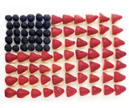

Ingredients Needed:
- 29 Large Strawberries
- 30 Large Blackberries
- 7 or so Large Bananas
- Lemon Juice

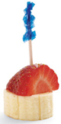
1. Hull and halve 29 large strawberries and set them aside.
2. Arrange 30 large blackberries, as shown, in the upper left corner of a serving tray or cutting board (it should be at least 8 by 13 inches).
3. Cut 58 banana slices, 3/4-inch-thick, into a bowl. Sprinkle on lemon juice and toss the slices gently with a rubber spatula to keep them from browning.
4. Assemble the banana slices in rows as shown and top each slice with a strawberry half.

