Top of Form
Chi Chi the Chihuahua Dog by Aurora
  
  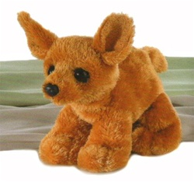
  Aurora Chi Chi the Chihuahua Dog - 8"
  Chi Chi the Chihuahua Dog by Aurora  Product Code: AR-16616
    Our Price: $4.99
    Qty:
  

  Description
  "Ay Chihuahua" This 8" plush Chi Chi the Chihuahua Dog by Aurora is the one you have been looking for. It has brown fuzzy fur that covers the entire body. The black eyes and black nose stand out against the brown hair. It is a wonderful stuffed puppy for anyone looking for a new friend. This item is for ages 3 and up.
  Features
  - Brown fur
  - Black eyes
  - 8" long
  - By Aurora
  Related Products...
  Aurora Sunshine the Orange Tabby Cat
  Our Price: $4.49
  Add
  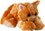
  Aurora Fifi the Pink Poodle Dog
  Our Price: $4.49
  Add
  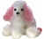
  Aurora Lola the Lhasa Apso Dog
  Our Price: $4.49
  Add
  
  Aurora Harvie Old English Sheepdog
  Our Price: $10.99
  Add
  Aurora Bailey the Cream Dog
  Our Price: $4.49
  Add
  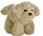
Bottom of Form
Found at www.stuffedsafari.com

