LifeWay’s VBS 2009
HELPFUL FACTS
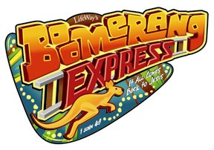

PLANNING
- The Administrative Guide for Directors now has perforated pages to allow directors to share pages with team leaders.
- More of the basic forms have been returned to the pages of the Administrative Guide for Directors.
- Among the many schedule options provided in the Administrative Guide for Directors is an option for a daily two-hour schedule.
- The price for all preschool and children’s Activity Paks (formerly known as Learner Guides) is now $2.29 each - .30 cheaper than 2008.

EVANGELISTIC RESOURCES
- The ABCs of Becoming a Christian video segment on the Worship Rally DVD is not theme-related and can be used for any children’s or family ministry event.
- ABC Wristbands proclaim the message, “It All Comes Back to Jesus.” Each package contains ten wristbands for kids and two for adults.

PRESCHOOL
- For the first time 3s—Pre-K and Kindergarten outlines are the same.
- Preschool Learner Guides have new titles, a new look, and a new purpose. Preschoolers and their parents will benefit from the newly designed Kid’s Activity Pak: for Babies-2s and the Kid’s Activity Pak: 3s-Kindergarten. Paks feature an interactive 16-page book with die-cut shapes, storage pocket for the shapes, a built in picture frame that is perfect for follow-up, and five daily activity cards designed to be used over-and-over at VBS and at home. The front of each card offers tips for parents on using the cards to continue Bible-learning at home and help their child make daily life application.
- The Bible-learning centers for 3s—Pre-K and Kindergarten (in Leader Guides) include a “Kid Connection” statement that tells how life application is made through each activity.
- The 3s—Kindergarten Rotation Pack Mission Folder DVD contains a special segment for the LifeBox* hands-on missions project. This segment provides additional information about the project and is recommended for teacher viewing only. There are three other DVD segments for preschoolers to see (one each for days 1, 3, and 5).
- Now preschoolers can continue singing the fun VBS 2009 songs at home. Music for Preschoolers CD includes seven songs – many of them Bible phrases put to music, and come five to the package.

CHILDREN’S BIBLE STUDY
- Children’s Leader and Learner Guides have been renamed to make it easier to identify resources with the school grades of the children. Leader Guides are now known as Grades 1-2 Bible Study Leader Guide, Grades 3-4 Bible Study Leader Guide, and Preteen Bible Study Leader Guide. Learner Guides are now called Kid’s Activity Pak: Grades 1-2, Kid’s Activity Pak: Grades 3-4, and VBX Activity Pak: Preteen.
- Grades 1-2 and Grades 3-4 Bible Study Leader Guides have a new layout format that includes a wide single column for text and a smaller side margin filled with great information. All preparation steps are listed by the step directions.
- Kid’s Activity Paks include five activity cards, two sets of Challenge Boomerangs (one using KJV and one using HCSB), a Return Trip Ticket that churches can customize, the ABCs of Becoming a Christian, and a suitcase picture frame that turns the pak into a follow-up resource. The Boomerang Challenge for each day will help kids determine how they will apply what they are learning to their lives.
- Each of the three Bible Study Leader Guides for grades 1-Preteens contains a Boomerang Challenge especially for teachers! Why just ask the kids to take the challenge? Found on page 15 of the Grades 1-2 and Grades 3-4 Bible Study Leader Guides and on page 48 in the Preteen Bible Study Leader Guide, teachers are given their own daily Boomerang Challenge that connects the Bible study to life.

CHILDREN’S ROTATIONS
- Crafts Rotation ideas are divided by age-groups not Bible, Theme, and Cost Saver. The divisions are appropriate for Grades 1-2, Grades 3-4, and All Ages.
- 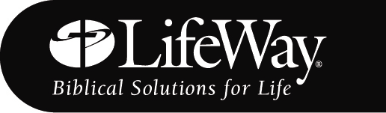The Crafts Rotation has a section each day called “Connection Points.” These talking points help craft leaders make the Bible connection with kids no matter which craft option is chosen.
- Crafts for Preteens will be in the back of the Leader guide instead of on the CD-ROM.
- Like the Crafts Rotation Leader Guide, the Music Rotation Leader Guide includes a “Connection Points” section for each day. Music leaders can now make the Bible connection with kids.
- The Music Rotation Leader Guide DVD includes the Boomerang Express theme song and motion demonstrations.
- The Missions Rotation Leader Guide now has a four-color insert with maps and visuals. The missions DVD includes an extra video segment explaining the LifeBox* hands-on mission project which churches may choose for their mission action project.
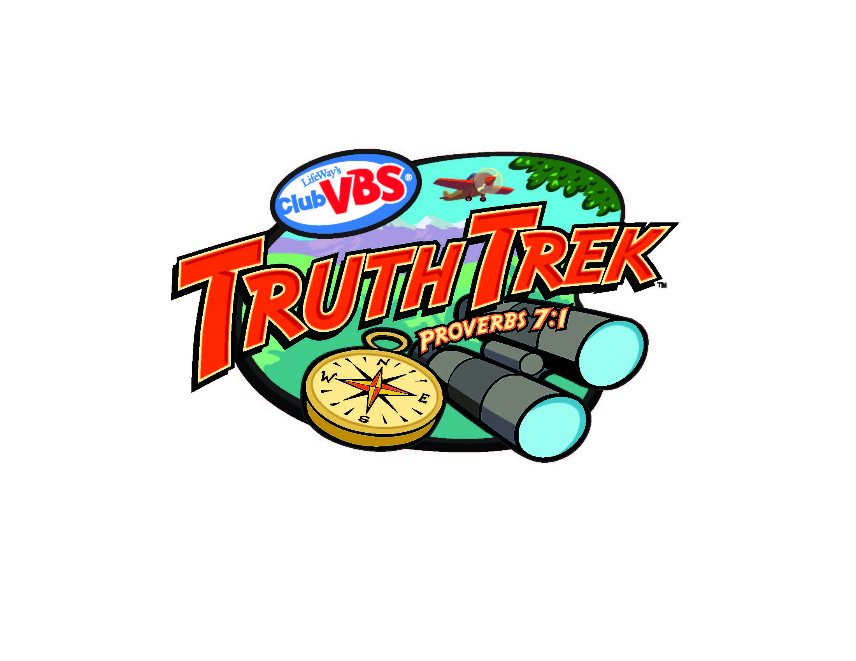
- Recreation cards have one Bible related game per day. The remaining games are designated by age-appropriateness and may be used at any time during the week. There are ten games for Grades 1-2, ten for Grades 3-4, and six for VBX Preteens. Additional Preteen games can still be found in the VBX Bible Study Leader Guide.

WORSHIP RESOURCES
- This year’s Worship Rally video is in the form of daily travelogues that introduce kids to some of the sights and places of interest in Australia, as well as taking them on location in Israel to sites that are connected with the daily Bible stories. Each segment sets the stage for the day’s study about Peter and his relationship with Jesus Christ. Video segments call for audience participation so encourage kids to respond!
- Video files on the Worship Rally DVD are now compatible with MediaShout®.
- The Worship Rally DVD contains a beautiful music video of Jeff Slaughter filmed on location in Israel of the Day 3 song, “Because.”
- The Worship Rally DVD contains great scenic footage of Australia and has multiple uses.

SPANISH RESOURCES
- Spanish resources can now be purchased in a Sampler that includes leaders guides for both preschool and children, a Leader Pack, music and more.

YOUTH RESROUCES
- VBS 2009 for youth is called the Rock and Reef Tour and is ideal for camps, retreats, Wednesday nights, as well as VBS.

PROMOTION & DECORATIONS
- The VBS 2009 Boomerang Express Bookmark looks like a train track. They’ll be easy to place end-to-end for a table display or for use as a bulletin board border. The back contains children’s daily session titles and the Scripture reference for the daily Bible verse, making it easy for kids to know where to mark the verses.
- Wait until you see the three new Quick Scene Super-sized Backdrops. One is the Sydney Opera House and Skyline, one is the Boomerang Express Train Dept, and one is Ayers Rock and the Outback. Each backdrop is six-by-nine feet. You will want one for each wall of your classroom.
- Fun promotional items and accessories this year include a Koala Clip-on, Outback Whirleys, Outback Tabletoppers, Outback Crossing Signs, Boomerang Express Bandannas, Floor Boot Prints, Giant Kangaroo Inflatable, Koala Inflatable, Boomerang Express Flyers, Boomerang Express Napkins, Outback Travel Decals, and a train whistles that sounds so real you’ll stop and wait for the train to come down the track!
- Invite the neighbors with the VBS 2009 Yard Signs. Each package contains 2 12x18 inch weather-resistant corrugated plastic signs and two 24 inch metal display rods.
PROMOTION & DECORATIONS
- Bulletin Board Set for Club VBS has changed to Bulletin Board Punch-Outs that includes six unique 8¾-by-24-inch sheets.
- New this year is a set of three large Decoration Posters to decorate hallways, classrooms, and the Worship Rally. Each poster is 25½ by 38½. Posters include the Truth Trek logo, Truth Trek motto, and a theme-related illustration.

STAY INFORMED
As always, get the latest VBS news and updates at www.lifeway.com/vbs.

*The mission of LifeBox is to fulfill the dream of a Southern Baptist Army officer to provide LifeWay’s distinctly Christian magazines to deployed military personnel, in response to the large amount of secular magazines available to them. Christian military personnel are seeking to grow spiritually and want to read uplifting articles and devotionals that will help them continue to grow spiritually, while they are away from their families and churches. For more information go to www.lifeway.com and type in LifeBox.

