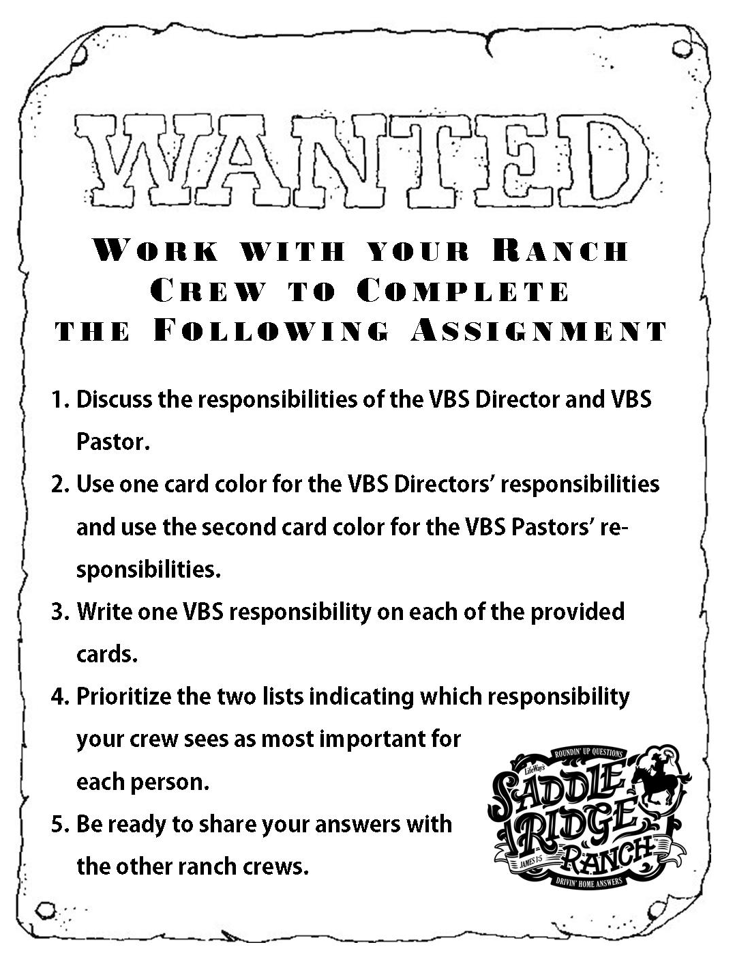
File 1 – VBS 2010 Item 3: Hit the Trail! Ranch Crew Assignment

