Fingerprint Fruits and Flowers

CRAFT MATERIALS:
- Flowers
- Fruit (bananas, apples, cherries, oranges)
- Paint
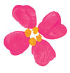

- Flowers: For each petal, press your paint covered index finger against the paper or cloth and roll it from side to side. Add small dots of paint with your pinkie.
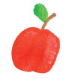

- Apple: Use your index finger to make two side-by-side overlapping vertical prints. Draw a marker stem and add a pinkie – print leaf.

- Pear: Use your index finger to make two make to overlapping perpendicular prints. Draw a marker stem and add a pinkie-print leaf. Once the pear is draw, add a marker dot to the bottom of the pear.
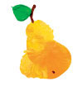

- Orange: Draw a large circle with the tip of your index finger. Add a marker stem and a pinkie-print leaf. Once the orange is dry ad a star on the bottom.
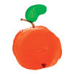

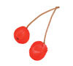
- Cherries: Make circles with the tip of your index finger, and then draw marker stems. Once the paint is dry, add marker Dots on the bottom of the cherries.

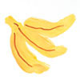
- Bananas: Draw a curved yellow streak with your index finger, then draw two more, one on either side. Once the paint is dry, add marker details.

Craft taken from family fun magazine (June Edition)

