DLTK's Crafts for Kids  Caterpillar to Butterfly craft  Thanks to Debbie for sharing her craft idea!  This is a simple three dimensional craft that is easy and fun for children to make and play with. Older children can cut the toilet paper rolls in half for more "joints" in their caterpillar (this is what we did in our photo). Younger children will want to leave the toilet paper rolls whole as it can be tough to cut them.  Helpful hint from Debbie:  We did this as a group activity in Sunday School with children age 2-4. The theme was “Live a new life for Jesus.” First, we painted our wings to allow time to dry in the oven. Then we did the caterpillar, read a story (which allowed the caterpillars to dry) about a caterpillar that became a butterfly and finished the project. The kids loved watching their caterpillar become a butterfly when we added the wings. | 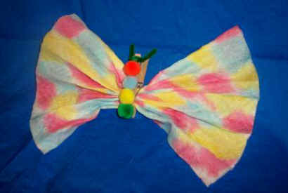

Materials
- Pinch-type clothes-pin
- Medium-size pom-poms
- School glue
- Pipe cleaner
- Paper towel (white)
- Water
- Food coloring
- Paint brush

Instructions:
Caterpillar:
- Glue pom-poms onto one side of clothes-pin. Twist 3 inch piece of pipe cleaner around top end to form antenna
- Let dry..
Butterfly wings:
- Lay paper towel flat.
- Mix water and food coloring to make “paint.” Use paint brush to paint the paper towel. The more colors you use, the more colorful the butterfly. Allow to dry. (To speed drying time, place on cookie sheet in oven on LOW temp.)
- When dry, fan fold the paper towel into approx. ½ inch sections.
Caterpillar becomes a Butterfly:
- Pinch the middle of the wings and clip inside the clothes-pin.

