Sneaker Leap
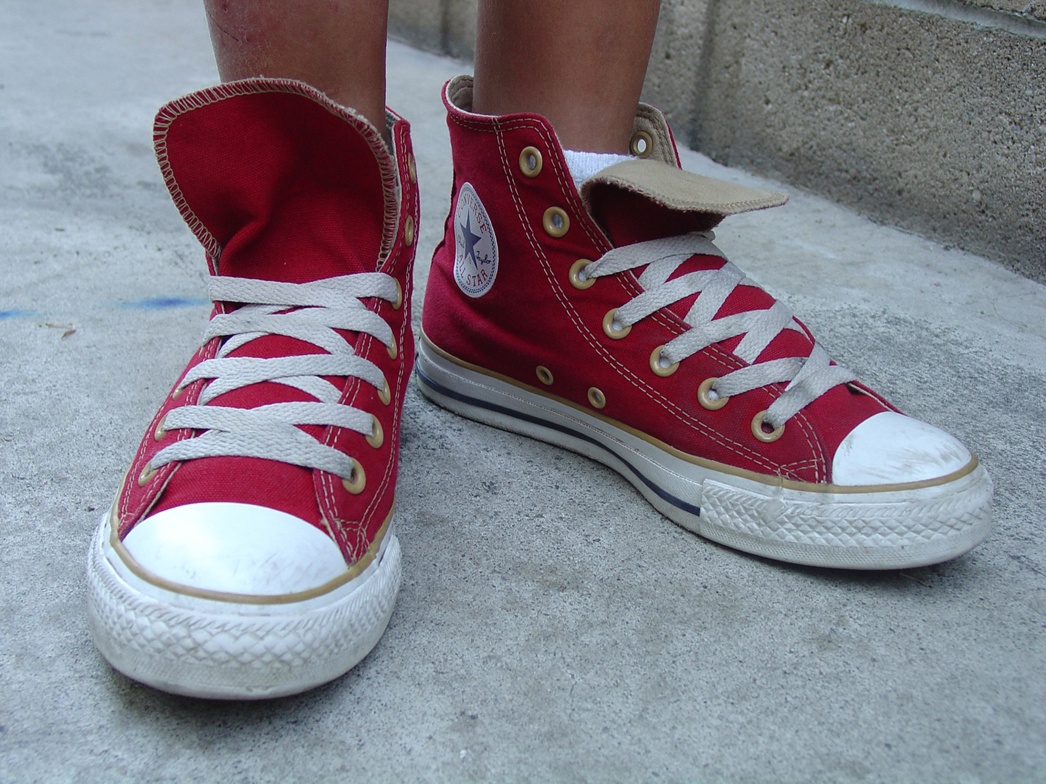

Tie an old sneaker to one end of a 7-foot length of rope. Squat down and swing the sneaker in a circle at a slow but constant speed, transferring the rope from hand to hand as it goes around you. Have a child stand in one spot and jump over the sneaker when it reaches him. Let the kids take turns jumping as well as spinning the rope.

(Game idea taken from the Family Fun Magazine July/August 2008 Edition)

